BANK LOAN SQL QUIRE DOC

- BANK LOAN REPORT | SUMMARY
KPI’s:
TOTAL LOAN APPLICATIONS
SELECT COUNT(id) AS Total_Applications FROM bank_loan_data
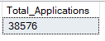

MTD LOAN APPLICATIONS
SELECT COUNT(id) AS MTD_Total_Applications FROM bank_loan_data
WHERE MONTH(issue_date) = 12
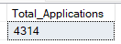

PMTD LOAN APPLICATIONS
SELECT COUNT(id) AS PMTD_Total_Applications FROM bank_loan_data
WHERE MONTH(issue_date) = 11
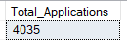

TOTAL LOAN AMOUNT ISSUED EACH MONTH FROM YEAR THE 2021
SELECT
DATE_FORMAT (issue_date, '%Y-%m') AS month,
SUM(loan_amount) AS total_loan
FROM bank_loan_data
GROUP BY DATE_FORMAT(issue_date, '%Y-%m');

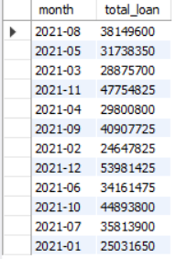

FIND HIGHEST LOAN MONTH
SELECT
DATE_FORMAT(issue_date, '%Y-%m') AS month,
SUM(loan_amount) AS total_loan
FROM bank_loan_data
GROUP BY DATE_FORMAT(issue_date, '%Y-%m')
ORDER BY total_loan DESC
LIMIT 1;

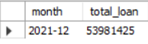

TOTAL FUNDED AMOUNT
SELECT SUM(loan_amount) AS Total_Funded_Amount FROM bank_loan_data
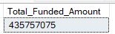

MTD TOTAL FUNDED AMOUNT
SELECT SUM(loan_amount) AS MTD_Total_Loan_Amount FROM bank_loan_data
WHERE Month(issue_date) = 12;
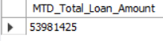

PMTD TOTAL FUNDED AMOUNT
SELECT SUM(loan_amount) AS PMTD_Total_Loan_Amount FROM bank_loan_data
WHERE Month(issue_date) = 11;
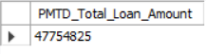

TOTAL AMOUNT RECEIVED
SELECT SUM(total_payment) from bank_loan_data;
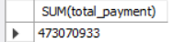

MTD TOTAL AMOUNT RECEIVED
SELECT SUM(total_payment)AS MTD_Total_amonut_recieved FROM bank_loan_data
WHERE MONTH(issue_date) = 12;
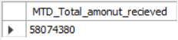

PMTD TOTAL AMOUNT RECEIVED
SELECT SUM(total_payment)AS PMTD_Total_amonut_recieved FROM bank_loan_data
WHERE MONTH(issue_date) = 11;
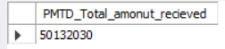

AVERAGE INTEREST RATE
SELECT Avg(int_rate) * 100 AS Avg_Interest_Rate FROM bank_loan_data;
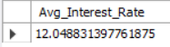

MTD AVERAGE INTEREST RATE
SELECT Avg(int_rate) * 100 AS MTD_Avg_Interest_Rate FROM bank_loan_data
WHERE MONTH(issue_date) = 12;
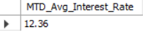

PMTD AVERAGE INTEREST
SELECT AVG(int_rate)*100 AS PMTD_Avg_Int_Rate FROM bank_loan_data
WHERE MONTH(issue_date) = 11;
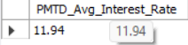

AVG DTI
SELECT round(Avg(dti) * 100 , 2) AS Average_DTI FROM bank_loan_data;
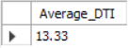

MTD AVG DTI
SELECT round(Avg(dti) * 100 , 2) AS MTD_Average_DTI FROM bank_loan_data
WHERE MONTH(issue_date) = 12;
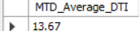

PMTD AVG DTI
SELECT round(Avg(dti) * 100 , 2) AS PMTD_Average_DTI FROM bank_loan_data
WHERE MONTH(issue_date) = 11;
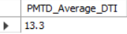

GOOD LOAN ISSUED:
GOOD LOAN PERCENTAGE
SELECT
ROUND(
SUM(CASE
WHEN loan_status IN ('Fully Paid', 'Current') THEN 1
ELSE 0
END) * 100.0 / COUNT(*)
, 2) AS good_loan_percentage
FROM bank_loan_data;
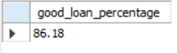

GOOD LOAN APPLICTION
SELECT COUNT(id) FROM bank_loan_data
WHERE loan_status = 'fully paid' OR loan_status = 'Current';
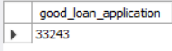

GOOD LOAN FUNDED AMOUNT
SELECT SUM(Loan_amount) AS Good_Loan_Funded_Amount FROM bank_loan_data
WHERE loan_status IN ('fully paid' , 'current');
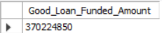

GOOD LOAN TOTAL RECIVED AMOUNT
SELECT SUM(total_payment) AS Good_Loan_Total_Recived_Amount FROM bank_loan_data
WHERE loan_status IN ('fully paid' , 'current');
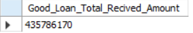

BAD LOAN ISSUED:
BAD LOAN PERCENTAGE
SELECT
ROUND(
SUM(CASE
WHEN loan_status = 'Charged Off' THEN 1
ELSE 0
END) * 100.0 / COUNT(*)
, 2) AS bad_loan_percentage
FROM bank_loan_data;
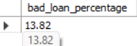

BAD LOAN APPLICATIONS
SELECT COUNT(id) AS Bad_Loan_Application FROM bank_loan_data
WHERE loan_status = 'Charged off';
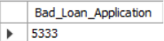

BAD LOAN FUNDED AMOUNT
SELECT SUM(loan_amount) AS Bad_Loan_Funded_Amount FROM bank_loan_data
WHERE loan_status = 'Charged off';
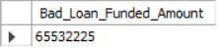

BAD LOAN TOTAL RECIVED AMOUNT
SELECT SUM(total_payment) AS Bad_Loan_Total_Recieved_Amount FROM bank_loan_data
WHERE loan_status = 'Charged off';
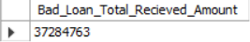

LOAN STATUS
SELECT
loan_status,
COUNT(id) AS Total_Loan_Application,
SUM(total_payment) AS Total_Amount_Received,
SUM(loan_amount) AS Total_Funded_Amount,
AVG(int_rate * 100) AS Interest_Rate,
AVG(dti * 100) AS DTI
FROM
bank_loan_data
GROUP BY
loan_status;
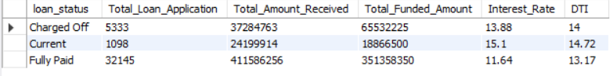

MTD TOTAL AMOUNT RECEIVED – GRID VIEW
SELECT
loan_status,
SUM(loan_amount) AS Total_Funded_Amount,
SUM(total_payment) AS Total_Amonut_Recived
FROM bank_loan_data
WHERE MONTH(issue_date) = 12
GROUP BY loan_status;
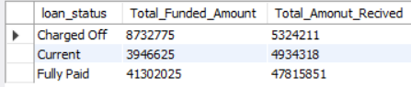

- BANK LOAN REPORT | OVERVIEW
MONTHLY TRENDS BY ISSUE DATE
SELECT
MONTH(issue_date) AS month_number,
MONTHNAME(issue_date) AS month_name,
COUNT(id) AS total_loan_application,
SUM(loan_amount) AS total_funded_amount,
SUM(total_payment) AS total_amount_received
FROM bank_loan_data
GROUP BY MONTH(issue_date), MONTHNAME(issue_date)
ORDER BY month_number;
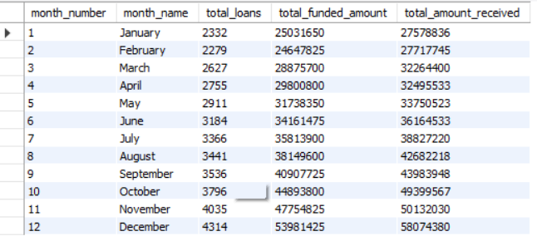

STATE
SELECT
address_state AS State,
COUNT(id) AS total_loan_application,
SUM(loan_amount) AS total_funded_amount,
SUM(total_payment) AS total_amount_received
FROM bank_loan_data
GROUP BY address_state
ORDER BY address_state ;
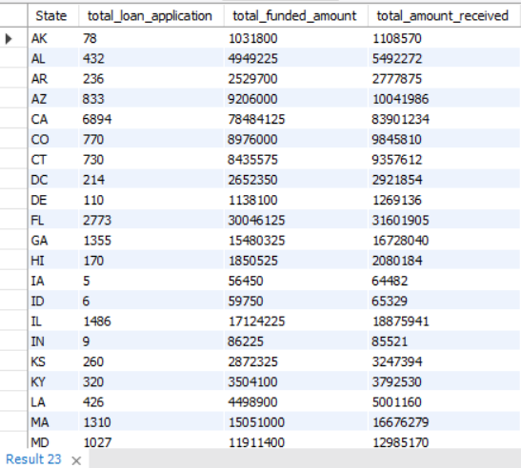

TERM
SELECT
term,
COUNT(id) AS total_loan_application,
SUM(loan_amount) AS total_funded_amount,
SUM(total_payment) AS total_amount_received
FROM bank_loan_data
GROUP BY term
ORDER BY term;
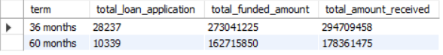

EMPLOYEE
SELECT
emp_length AS Employee,
COUNT(id) AS total_loan_application,
SUM(loan_amount) AS total_funded_amount,
SUM(total_payment) AS total_amount_received
FROM bank_loan_data
GROUP BY emp_length
ORDER BY emp_length;
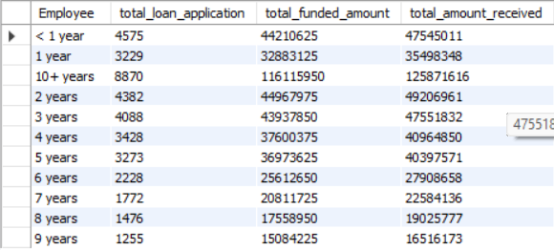

PURPOSE
SELECT
purpose,
COUNT(id) AS total_loan_application,
SUM(loan_amount) AS total_funded_amount,
SUM(total_payment) AS total_amount_received
FROM bank_loan_data
GROUP BY purpose
ORDER BY purpose;
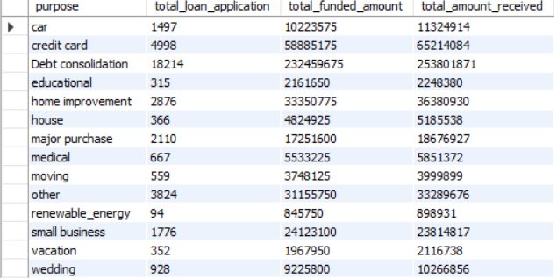

HOME OWNERSHIP
SELECT
home_ownership,
COUNT(id) AS total_loan_application,
SUM(loan_amount) AS total_funded_amount,
SUM(total_payment) AS total_amount_received
FROM bank_loan_data
GROUP BY home_ownership
ORDER BY home_ownership;
